

ANNUAL CHARITY GOLF TOURNAMENT

At Fort Jackson

On

Monday, September 10th, 2018

* 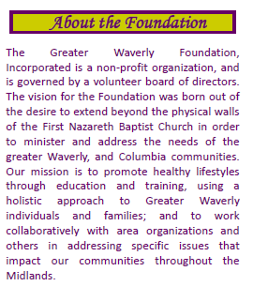Registration Form: Captain’s Choice
* Team of Four Suggested

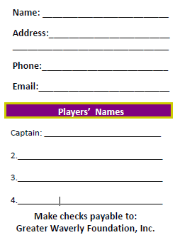$75.00 per player / Team Sponsorship $300

* Cont. Breakfast, Lunch & Snacks

* Registration and Practice balls 7:45 am, Prayer and Line-up 8:45 am Shotgun start 9:00 / Lunch 12:30 pm

**Register On-line at www.thegreaterwaverlyfoundation.com**

**(Deadline to Register is September 1, 2018)**

Use the Forest Drive Gate to enter, Allow 15 minutes to clear Fort Jackson’s Entrance: Mention to Guard – Greater Waverly Golf tournament (your name should be on a list), Please bring license / Photo ID (if driving have car registration & insurance information). Call 446-5907 if any issues.